2.1 Sample 1. Gravel Pit Soil Sample:
Sample 1 was obtained near the gravel pit near the north-west boundary of RRU. The quarried gravel pit area was approximately 10 metres deep with a diameter of approximately 25 metres. The sample was obtained just south of the gravel pit from an undercut bank dominated by second growth Douglas-fir forest. The undercut bank was 4 metres high with a west slope aspect. An accumulation of materials from the top of the bank had slumped to the base of the bank.
At the top of the bank there was a large Douglas-fir with an extensive network of roots that protruded below the litter horizon and outward from the face of the concave slope. The face of the slope was cleaned with a shovel and trowel.
The profile of the soil horizon is illustrated below in Figure 3.
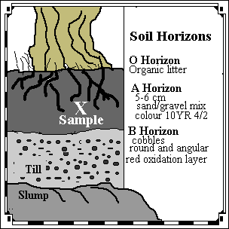
Figure 3. Profile of Soil Horizon for Sample 1 at Gravel Pit.
The O horizon of organic material was composed of leaf litter, coniferous needles, mosses and small herbaceous plants less than 2 cm tall. The A horizon was 5 to 7 cm thick. The lower portion blended into the B horizon with no distinct delineation. The B horizon was comprised of rounded and angular cobbles, 2 to 5 cm diameter, in a coarse sand matrix. There was a distinct reddish layer characteristic of oxidation processes. The C horizon was not distinguishable. The lower portion of the slope face was not visible due to slumping of the materials from the upper portion of the slope face.
The sample was obtained one metre below the surface of the O horizon. The soil sample was a dark grey-brown. The Munsell soil colour of the sample was 10YR 4/2 (Munsell, 1994). The sample was a sand and gravel mixture with angular and rounded cobbles in the sand matrix. Approximately 1 litre of the sample was collected into a plastic bag and labelled "Soil Sample 1" and returned to the laboratory for analysis.

2.2 Sample 2. Lower Field Soil Sample:
Sample 2 was obtained in the lower field near the Esquimalt Lagoon at the south-west boundary of RRU. The grassy field was approximately 25 by 25 metres. There was a large stand of alder trees at north edge of the field. The field was hummocky and uneven; it has been used in the past as cow pasture land. The dominant vegetation in the field was herbaceous grasses with 5 percent cover of Scotch Broom which is an exotic species. The sample was obtained in the north-west corner of the field. The slope gradient was approximately 7 degrees with a south aspect. The grassy field was very waterlogged.
The sampling site was randomly selected and the upper turf layer was removed and put aside. A small pit, 50 cm wide by 70 cm deep, was dug with a shovel until the water pooled at the bottom of the pit. The sample face was cleaned with a small trowel.
The profile of the soil horizon is illustrated below in Figure 4.
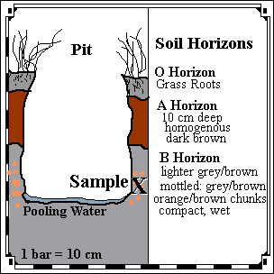
Figure 4. Profile of Soil Horizon for Sample 2 at Lower Field.
The O horizon of organic material was composed of herbaceous grasses and the grass roots extended into the A horizon. The A horizon was 10 cm thick. It was a rich dark brown, loamy and homogenous. There was one earthworm in the A horizon. The lower portion leached downwards into the B horizon. The upper portion of the B horizon was comprised of a lighter grey-brown fine sand matrix. The lower portion of the B horizon had a fine wet compact matrix with coarse mottles of grey and orange brown clay-like materials. The bottom of the pit was covered by murky pooling water.
The sample was obtained 70 cm below the surface of the O horizon. The soil sample was from the section of mottled materials in the lower B horizon. The grey and orange brown colour approximates the Munsell soil colour 7.5YR 5/4 (Munsell, 1994). The sample was a compact clay matrix. Approximately 1 litre of the sample was collected into a plastic bag and labelled "Soil Sample 2" and returned to the laboratory for analysis.

3.3 Sieve Analysis:

3.3.1 Introduction:
The sieve analysis is used to determine the percent by weight of the sizes of the particles. The size of the particles provides information about the environment of deposition. Large heavy particles are deposited in high energy environments and small light particles are deposited in low energy environments. The particle size is used to determine whether the material is classified as a clay, silt, sand, or gravel.

3.3.2 Methods and Procedures:
The sieve analysis was completed on sample 1 and sample 2 to determine the grain sizes of the soil particles in the soil samples. The samples were obtained on January 23, 1998 from the locations illustrated in Figure 1: Map of Soil Sample Locations. The samples were returned to the lab to dry for one week; sample 1 was air dried and sample 2 was oven dried. Sample 2 was crushed with a mallet. The sieve analysis was completed as follows:
- Each sieve was weighed to 0.1 gram.
- 500 grams of the coarser (gravel pit) oven dried soil was weighed and broken into smaller particles.
- The sieves were arranged with the largest screen on top and proportionately decreasing screen size to down to the closed-bottom container. The soil sample was placed in the uppermost sieve, covered and shaken lightly, using a back-and-forth motion for for 10 minutes. The mode of shaking was alternated to move the grains continuously across the sieve screens with no definite pattern.
- Each sieve and the pan, with the retained soil was weighed to 0.1 gram. The sum of these retained weights was checked against the original soil weight.
- This procedure was repeated with sample 2 and 500 grams of the finest particles were retained for the Hydrometer analysis.

3.3.3 Results of the Sieve Analysis:
The results for the sieve analysis of sample 1 are contained in Table 3 below.
Table 3. Grain Size Analysis of Sample 1.
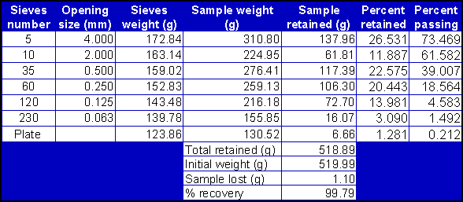
The results for the sieve analysis of sample 2 are contained in Table 4 below.
Table 4. Grain Size Analysis of Sample 2.
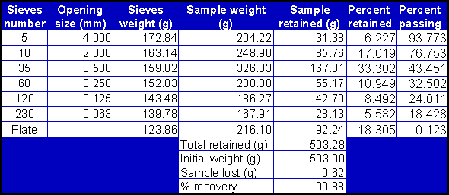
The results of the particle size and percent of particles for sample 1 and sample 2 are plotted on the gradation curves illustrated in Figure 5 below.
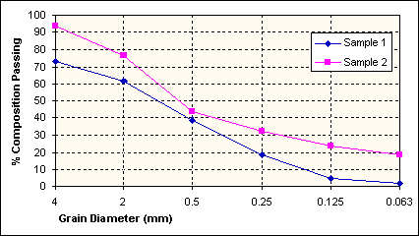
Figure 5. Graph of Grain Size Gradation Curves by Sieve Analysis for Sample 1 and Sample 2.
The results of the particle size and percent of fine clay and silt particles for sample 2 are treated in the Hydrometer Analysis section.

3.3.4 Discussion of the Results of the Sieve Analysis:
The comparisons of the two types of soil particle compositions are summarised in Table 5 below.
Table 5. Summary of Grain Size Types in Sample 1 and Sample 2 by Sieve Analysis.

Description | Grain Diameter (mm) | Sample 1 Percent Retained | Sample 2 Percent Retained
Gravel | >4.75 | 26.6 | 6.2
Coarse Sand | 0.420 to 4.75 | 34.5 | 50.4
Fine Sand | 0.075 to 0.420 | 34.5 | 19.5
Silt and Clay | < 0.75 | 4.4 | 23.9
Sample 1 had a higher percent composition by weight of gravel and coarser materials whereas sample 2 had a higher composition of finer grained materials. Sample 1 is composed of 26.6 percent gravel, 34.5 percent coarse-to-medium sand, 34.5 percent fine sand, and 4.4 percent silt and clay. Sample 2 is composed of 6.2 percent gravel, 50.4 percent coarse-to-fine sand, 19.5 percent fine sand, and 23.9 percent silt and clay. Sample 2 is a typical example of skip-graded soil. Based on the grain-size analysis and the gradation curves, both soil samples do not have good gradation.
This gradation curve is used in foundations and earthworks engineering (Kough, 1969). Soil characteristics can be predicted on the basis of this curve. A good gradation, characterised by a gentle even slope, is representative of a material that is relatively stable. This type of soil is resistant to erosion or scour, can readily be compacted to a very dense condition, and, will develop high shearing resistance and bearing capacity. These characteristics determine the suitability of the soil for certain purposes, such as housing and soil loading capacity. The latter is a critical to avoid landslide and other incidents related to overloading the landform. Moreover, because of the lack of standardisation of the ratio between percent finer and particle diameter scales, the actual slope of any given point can be misleading. Thus, uniformity coefficient is usually used to overcome this problem.
This sieve method of analytical procedure does have some limitations that decrease the accuracy of the results including: soil loss (especially colloid particles), inappropriate mode of sieving, and, insufficient time to allow total sieving so that the soil particles are perfectly sorted.

3.4 Hydrometer Analysis:

3.4.1 Introduction:
The hydrometer analysis is used to determine the percentage of clay in the soil sample. The hydrometer measures the cohesiveness of the soil sample. This is a measure of the ability of the soil particles to "stick" to one another. Hydrometer analysis is a good indicator of the clay content of a soil because the behaviour of the soils’ cohesive portion is very dependent upon the clay content of the soil. Other soil properties including water content, particle sizes, and geologic history also influence the hydrometer analysis but these properties have less impact on the results of the hydrometer analysis.

3.4.2 Methods and Procedures:
The hydrometer analysis was completed on sample 2 to determine the clay percentage of the soil. The sample was obtained on January 23, 1998 from the location illustrated in Figure 1: Map of Soil Sample Locations. The sample was returned to the lab to air dry for one week. The sample was crushed with a mallet and analysed for pH and grain size. Five hundred grams of the sample was sorted by passing it through a series of screens. The soil that passed through the number 230 sieve, a very fine screen, was collected and labelled for the hydrometer analysis. Fifty grams of this soil was mixed with the dispersing (deflocculating) agent sodium hexametaphosphate. The mixture was added to a sedimentation cylinder and topped up with distilled water to a volume of 1000 mL. A control cylinder containing distilled water and deflocculating agent was also tested. This allowed a zero correction to be made which would cancel the effect of the deflocculating agent upon the solution density. Hydrometer and temperature readings were taken at specific time intervals over the next two days.

3.4.3 Results of the Hydrometer Analysis:
The results of the hydrometer analysis are summarised detailed in Table 6 below.
Table 6. Grain Size of Sample 2 by Hydrometer Analysis.

Time (min) | Temp (C) | Hyd  (R_{a}) | Hyd  (R_{e}) | Percent Finer | Hyd Cor | L | K | D (mm)
0.5 | 18.4 | 48 | 42.5 | 84 | 49 | 8.3 | .0138 | .0560
1.0 | 18.4 | 46 | 41.5 | 82 | 47 | 8.6 | .0138 | .0405
1.5 | 18.4 | 43 | 37.5 | 74 | 44 | 9.1 | .0138 | .0340
2.0 | 18.4 | 42 | 36.5 | 72 | 43 | 9.2 | .0138 | .0300
2.5 | 18.4 | 41 | 35.5 | 70 | 42 | 9.4 | .0138 | .0270
3.0 | 18.4 | 40 | 34.5 | 68 | 41 | 9.6 | .0138 | .0250
3.5 | 18.4 | 39 | 33.5 | 66 | 40 | 9.7 | .0138 | .0230
4.0 | 18.4 | 38 | 32.5 | 64 | 39 | 9.9 | .0138 | .0220
9.0 | 18.4 | 34 | 28.5 | 56 | 35 | 10.5 | .0138 | .0150
15.0 | 18.4 | 32 | 26.5 | 52 | 33 | 10.9 | .0138 | .0120
30.0 | 18.4 | 31 | 25.5 | 50 | 32 | 11.1 | .0138 | .0084
60.0 | 18.4 | 28 | 22.5 | 45 | 29 | 11.5 | .0138 | .0060
120.0 | 17.1 | 24 | 18.3 | 34 | 25 | 12.2 | .014 | .0044
420.0 | 17.1 | 22 | 16.3 | 32 | 23 | 12.5 | .014 | .0077
1020.0 | 16.0 | 20 | 14.1 | 28 | 21 | 12.9 | .014 | .0016
1080.0 | 17.1 | 21 | 15.3 | 30 | 22 | 12.7 | .014 | .0015
1800.0 | 17.5 | 19 | 13.3 | 26 | 20 | 13.0 | .014 | .0012
These results are plotted on Figure 6 below.
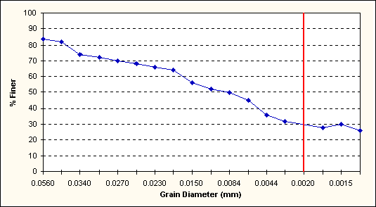
Figure 6. Graph of Grain Size of Sample 2 by Hydrometer Analysis.
According to the graph of percent finer vs. the log of the grain diameter in mm, the fine grained portion of the soils sample tested contains approximately 75 percent silt (.05 to .002 mm dia) and 25 percent clay (<.002 mm dia).

3.4.4 Discussion of the Results of the Hydrometer Analysis:
Analysis of the graph of percent finer vs. the log of the diameter size yields sample results of 75 percent silt and 25 percent clay. These percentages are approximations. Also, there are certain assumptions that are made when calculating Stokes equation. These include: no interference of particles by other particles or by the walls of the cylinder, all particles are spherical, and known specific gravity of the particles.
The first of these errors was eliminated by using only 50 grams of sample in the cylinder; however, experimental evidence indicates that hydrometer readings tend to yield diameter results that are smaller than their true value.

3.5 Permeability Analysis:

3.5.1 Introduction:
The permeability of a soil is a measure of the soils hydraulic conductivity or the ease that water will pass through the soil when exposed to a pressure gradient. Permeability is a very important soil property during groundwater study. It determines the rate at which water will migrate through an aquifer towards well heads. This information is necessary for setting well output rates to prevent draw-down and aquifer depletion. It is also essential for remediating contaminated groundwater. Soil permeability is important whenever projects involve water migration through soils. Projects such as reservoirs, dams, landfills and nuclear waste disposal sites all have a permeability factor that affects their design. Generally speaking the coarser the soil particles, the higher the permeability and the faster the flow. Thus coarse sands have a high permeability and fine grained silts and clays have a very low permeability.
It is impossible to duplicate field conditions within the lab and the experiment to determine soil permeability has some built in errors. The soil sample within the apparatus does not exactly duplicate the soil strata in the field. The smooth walls of the chamber do not mirror natural boundary conditions. In the lab, the hydraulic gradient is vertical whereas in the field, it can be horizontal. The hydraulic head applied in the lab may not be the same as that present in the field. However, lab experiments of this type do provide an adequate approximation of permeability provided that certain conditions are met. The flow rate, hydraulic head, and soil volume must all be constant and the soil must be saturated.

3.5.2 Methods and Procedures:
The permeability experiment was completed on sample 3 which was obtained on January 23, 1998 from the location identified in Figure 1 Map of Soil Sample Locations. The sample that was tested for permeability was different than that tested for pH, grain size and the hydrometer. This sample was collected from a roadside and was labelled "Middle sample, Permeability test". The collection site was approximately 5 meters from the side of a gravel road. The site was located on a slope of 15 degrees and was covered with small pebbles, pine needles and sparse grass. The cover was removed and a small hole approximately 20 cm deep was dug. The soil was a orange/brown in colour and appeared to consist mainly of fine to medium grained sand. The sample was bagged and labelled and returned to the lab.
Soil sample 3 was analysed in the lab using a constant head test. The flow through the sample was extremely slow. In order to accelerate the process, the hydraulic head was raised as high as the tubing permitted and each test was run for 15 minutes only. Channels developed in the soil during the test and the output was in steady slow drips. Apparently this soil was tested by other groups in the lab without difficulty. Problems that arose during this test may have been due to the presence of clay lumps and a non-homogeneous bag of sample soil.
In future, all soils should be mixed thoroughly to avoid this problem and allow good replicate results. A falling head test would be preferable for this type of soil. A higher hydraulic head and a smaller cylinder of soil would also speed up the process.
The apparatus is illustrated in Figure 7 below.
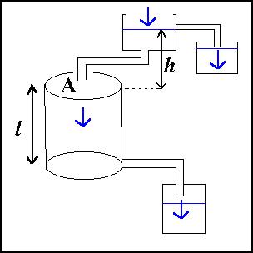
Figure 7. Illustration of the Apparatus for the Permeability Analysis.

3.5.3 Results of the Permeability Analysis:
The results of the volume of water and elapsed time are summarised in Table 7 below.
Table 7. The Volume of Output Water "Q" and Elapsed Time for Three Permeability Tests.

Test Trial No. | Volume of Water (mL) | Time (minutes)
1 | 80.0 | 15
2 | 70.0 | 15
3 | 52.0 | 15
Note: The average Q was calculated to be 67.3 mL per 15 minutes.
The calculation of the permeability coefficient "k" is detailed in Table 8 below.
Table 8. Calculation of the Permeability Coefficient "k" of the Soil Tested.

Q (mL/min) | Height of head "h" (cm) | Length of sample "l" (cm) | Cross sectional area "A" (cm²) | Permeability constant k (cm/sec)
67.3 | 32.0 | 13.2 | 31.65 | 0.0128
Note: From the Darcy's Equation Q=kAh/l

3.5.4 Discussion of the Results of the Permeability Analysis:
The permeability constant for the soil sample tested was calculated to be 0.0128 cm per second. This result indicates that the soil was a sand with some silt content which is consistent with the gross appearance of the sample. The variation in the volume of discharge per 15 minute intervals, prevously detailed in Table 7, could be accounted for by the non-uniformity of the sample. The water channels that were observed within the column could greatly affect the rate of discharge. Thus the permeability constant K that was calculated, has a large error component.

4.1 Introduction:
The classification of soil samples is based on the taxonomic Canadian system of soil classification. The broadest level of classification is the Order which is based on the properties of the soil pedon that reflect the nature of the soil environment and the effects of the dominant soil-forming process. The next level of soil classification is the Great Group which is based on the properties of the soil that reflects the less dominant soil soil-forming process. The third level of soil classification is the Subgroup which is based on the finer differentiation between the soil horizons.

4.2 Soil Classification:
The characteristics of the soil samples are summarised in Table 8 below. The methods to key out or distinguish between the great group level and the subgroup level are illustrated in Figure ?. The soil samples are classified in the Brunisol order. Both soils had a pH greater than 5.5 and thus are classified at the great group level as either Melanic Brunisols or Eutric Brunisol; however, both soils had Ah horizons that were less than 10 cm and consequently they are classified as Eutric Brunisols. Sample 1 had evidence of an eluvial oxidation layer in the B horizon and is classified as Eluviated Eutric Brunisol soil at the subgroup level. Sample 2 had coarse mottles within the 50-100 cm depth and is classified as Gleyed Eutric Brunisol soil at the subgroup level.

4.2.1 The Characteristics of the Soil Samples:
The major characteristics of the soil samples are summarised in Table 9 below.
Table 9. Characteristics of Soil Samples 1 and 2.

Characteristic | Sample 1 | Sample 2
pH | 6.5 | 6.2
A Horizon | 5 to 6 cm  Grey/Brown 10YR 4/2  Sand/Gravel | 10 cm  Brown 7.5YR 5/4  Loamy
B Horizon | Fluvial  Oxidation | Mottled
Gravel | 27 percent | 6 percent
Coarse Sand | 34 percent | 50 percent
Fine Sand | 34 percent | 19 percent
Silt | Silt/Clay combined is 4 percent | 18 percent
Clay | Silt/Clay comined is 4 percent | 6 percent

4.2.2 Keying out Soils of the Brunisolic Order:
This illustration in Figure 8 below facilitates keying out the classification of the soils. The classification criteria is derived from the Canadian System of Soil Classification. The key criteria to note are the pH levels and the thickness of the Ah horizon to determine the great group level. The processes identified in the soil horizons provide the additional information with which to determine the classification at the subgroup level.
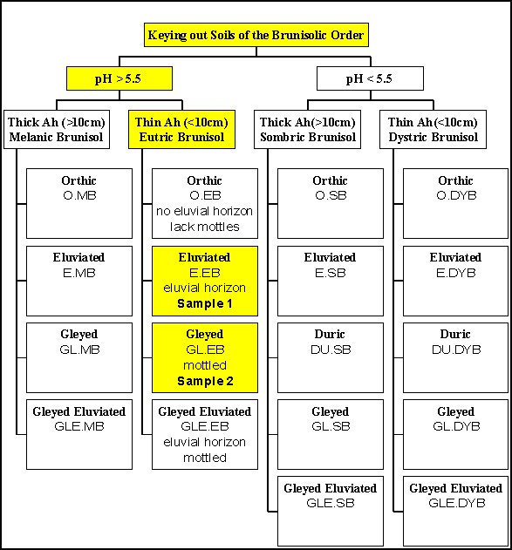
Figure 8. Keying out Soils of the Brunisolic Order.

4.3 Discussion and Conclusion:
The proposed soil classifications are based on the field observations and laboratory analysis. It is worthwhile to compare this analysis to other soil surveys completed and published regarding this study area.
The Madrone report identifies the dominant soils in this area as podzols (Madrone, 1995). It is important to recognise that the Madrone Report was primarily an analysis of the ecological communities of the study area rather than a comprehensive soil analysis. The key item to note is that there are significant similarities between the podzolic soils and the brunisolic soils. Brunisols are distinguished from podzols in that podzols have a podzolic B horizon and brunisols do not (Agriculture, 1987). Both soils have similar colour properties and chemical properties; however, the horizons of the brunisols are less defined.
The primary reference document for the classification of soils in the study area is the MOE Technical Report 17 which maps the soils of southern Vancouver Island by soil association and identifies the most common soil classifications (Jungen, 1985). The soil associations mapped for this area are the Quamichan or the Saanichton. The most common soil types are Orthic Dystric Brunisols or Orthic Sombric Brunisols respectively. The Orthic Brunisols are acidic with a pH less than 5.5; hence, our proposed soils classifications are excluded from the Orthic Brunisol subgroup. It is important to recognise that this is based exclusively on our analysis of the pH of the soil solution which was very close to the determinant level of pH 5.5.
The properties of soils can vary between samples obtained within a small area. The differentiation between the subgroup Melanic Brunisol and Eutric Brunisol is based on the thickness of the Ah horizon. The Ah horizon of sample 2 was approximately 10 cm so it could possibly be classified as either Melanic or Eutric. In addition, it would be very possible to have differences of 2 cm in the Ah horizon between two sampling locations that would differentiate between subgroup classifications.
In conclusion, both samples are brunisols. Sample 1 is classified as an Eluviated Eutric Brunisol and Sample 2 is classified as a Gleyed Eutric Brunisol.

